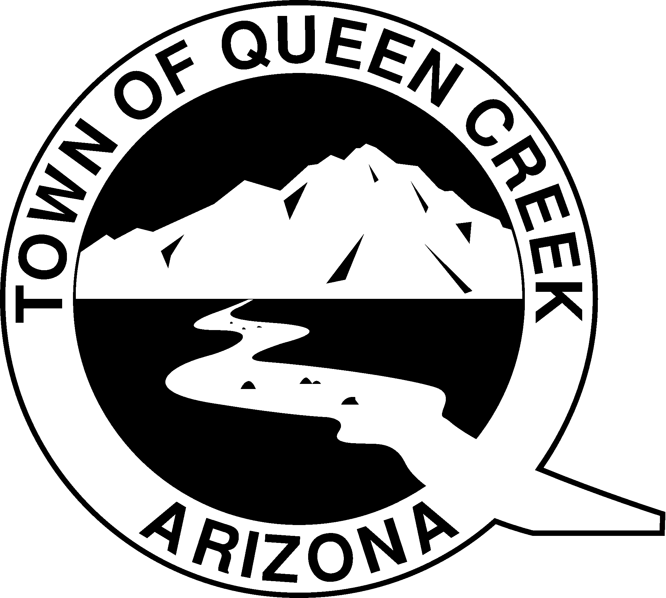

**Town of Queen Creek**

**FY 2025-2026**

**Not-For-Profit Funding**

**Checklist**

The application and other required information must be returned by

December 8, 2024 to:

[**Kim.Nishihara@QueenCreekAZ.gov**](mailto:Kim.Nishihara@QueenCreekAZ.gov)

For questions, contact Kim Nishihara at (480) 358-3216 or kim.nishihara@queencreekaz.gov

**GENERAL INFORMATION**

As part of the annual budget development process, the Town of Queen Creek may allocate funding to not-for-profit agencies whose projects/programs/events/services benefit the Queen Creek community.

**SCHEDULE OF DATES**

Applications open and accepted starting on November 4, 2024

Grant deadline – last day to apply December 8, 2024

Town Council Budget Committee consideration Spring 2025

Notification of funding status for FY 2025 - 2026 May 2025

**APPLICATION CHECKLIST**

* Application Checklist
* Application
* Most recent financial audit of organization (See Note 1 below)
* Most recent IRS Form 990N (applicants must submit a current 990N form for applications to be complete)
* W-9

**Note 1**: If the requesting agency does not have an annual financial audit, please enclose the most recently completed fiscal year unaudited financial statements.

**Failure to submit a complete application package in the requested format by the due date may disqualify a program or agency from consideration for Fiscal Year 2025-2026 funding.**